1. Write a program that displays “Hello” in one line, and “World” in another line using exactly two (2) COUT statements.

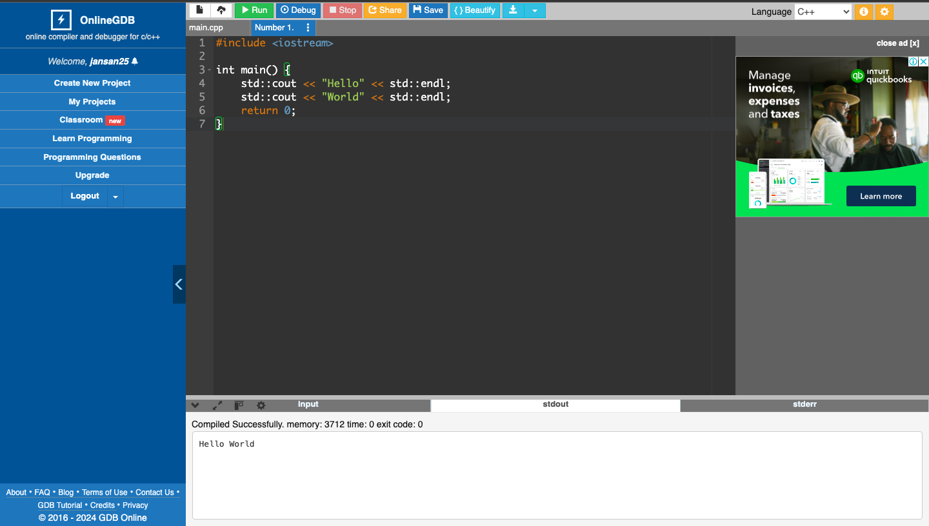

1. Write a program that displays “Hello” in one line, and “World” in another line using exactly ten (10) COUT statements.

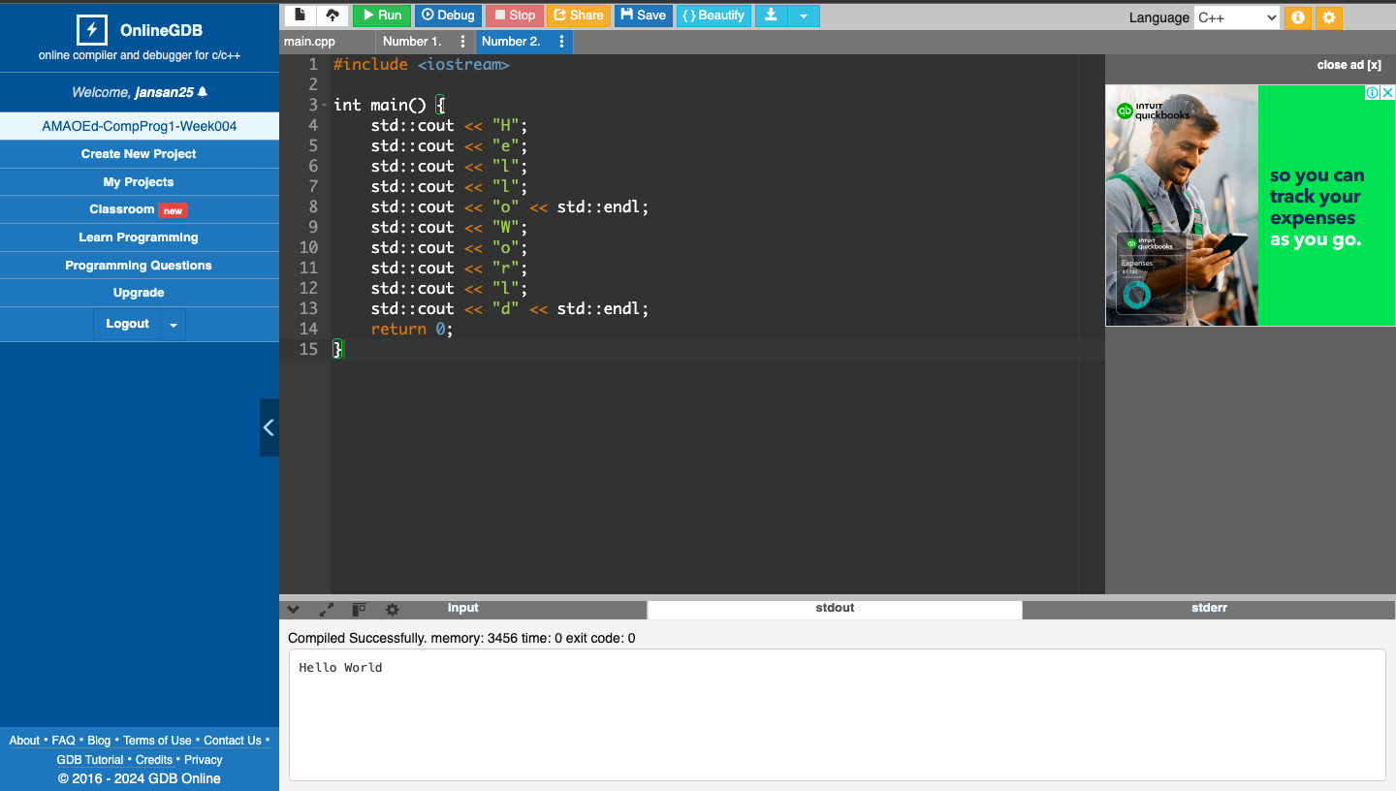

1. Write a program that displays “Hello” in one line, and “World” in another line using exactly one (1) for the “Hello” and exactly five (5) COUT statements for the “World”.

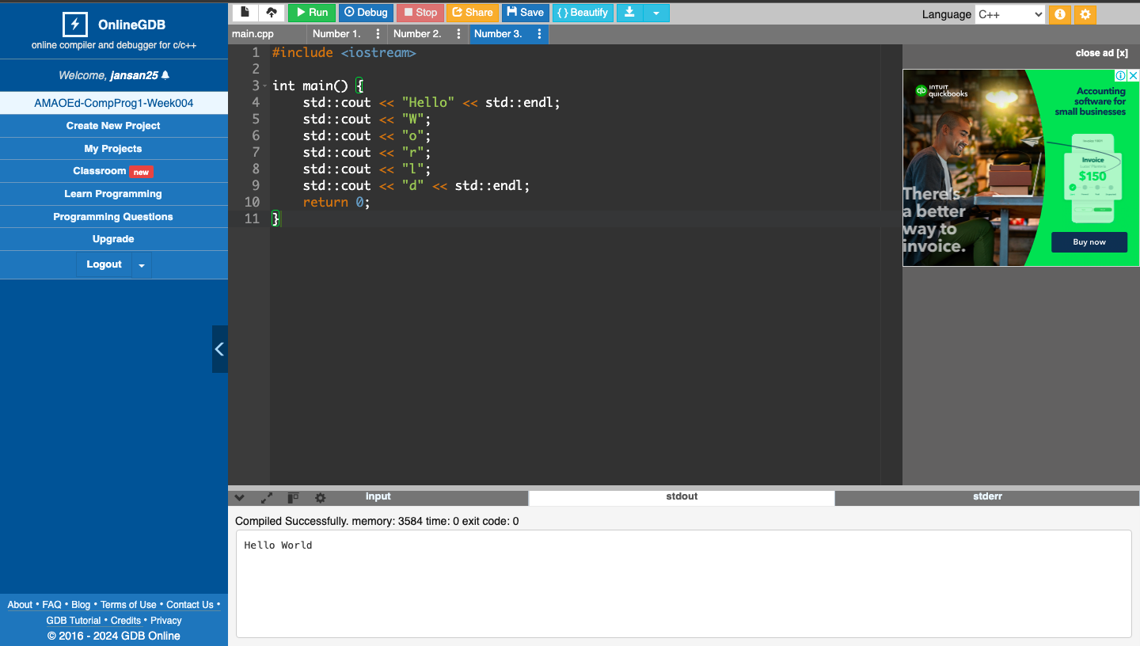

4.   What can you conclude from this activity?

This lab exercise is beneficial for me as I am making strides toward becoming a programmer. I'm currently coding and exploring new concepts. Even though this task is simple, it provides valuable insights as I begin my learning journey. Learning to print "Hello World" may seem basic, but it is incredibly helpful for me.